Kindergarten Curriculum Guide

Kindergarten at M.C.H.V.F. provides an enriching and diverse learning experience. In all areas of the kindergarten curriculum, students learn according to their developmental level and are guided through each learning experience to achieve success. The Kindergarteners progress academically and socially through a variety of creative and challenging learning experiences. The effort of the last three years at M.C.H.V.F comes to fruition as their language and math skills blossom and a lifelong curiosity and love of learning is instilled.

Each year the Kindergarteners study seven different countries. The curriculum integrates the customs, architecture, art, music, food, dress, and literature from each country studied. We invite guests to share experiences and stories of other cultures. The Kindergarteners will also have an opportunity to try different food from around the world during our annual International Luncheon. They will have the opportunity to go on a field trip to Philadelphia during the year as well.

Language Arts
The kindergarten program presents students with many opportunities to develop their emerging reading, writing, listening, speaking, and handwriting skills through formal and informal instruction. They are encouraged to use inventive spelling (spelling a word by its sound, spelling phonically and typically using one letter for each sound) and conventional spelling in their yearbooks, journals, story writing and their sound of the week books.

Journal
Journal entries include factual information about the seven countries we will be studying. The children are encouraged to write about topics relevant to their lives, i.e., weekend activities, holidays, etc. The journal entries also include child drawn illustrations.

Yearbook
Yearbook entries are typically about different events and experiences the Kindergarteners will have throughout the year, and include photographs taken at the events documented.

Sight Words
The Kindergarteners are introduced to a new high-frequency word every week. They will have the opportunity to practice writing and reading these words and will be encouraged to locate them in their reading books.

Rhyming/Word Families
The Kindergarteners explore rhyming through several activities. These activities include brainstorming and recording rhyming words, listening to stories with rhyming words, and making a rhyming wheel each week.

Reading
The Kindergarteners are given the opportunity to learn to read at his/her own pace. We use a variety of reading series to meet the needs of all our students. They read one-on-one with a teacher and will also have an opportunity to read to the Readiness class.
We encourage you to supplement your child’s daily reading by having them practice with you at home as much as possible, as reading skills get better with practice.

Handwriting
The Kindergarteners are exposed to the correct way to form letters and numbers on a daily basis. They also have a Handwriting Practice Book that is used on a Friday in conjunction with “Sound of the Week.” We follow the Handwriting Without Tears curriculum.

Workbooks
We use the series Explode the Code, Beyond the Code, and Primary Phonics by Educators Publishing Services. These workbooks supplement the learning going on in the classroom.

Math
The Kindergarteners are introduced to the concepts of addition, subtraction, multiplication, and division. They are also introduced to time, money usage, fractions, place value, graphs, and units of measurement. All these concepts are taught using the Montessori materials.
Math Workbook: Fast Facts by Primary Concepts, which reinforces essential addition and subtraction math facts.

Science
The Kindergarteners participate in simple science experiments through sensorial exploration each month. They also keep a science journal of all the experiments. The Kindergarteners will participate in a Science Fair in the spring as well.

Art
The Kindergarteners are spilt into two groups (by class) every Thursday afternoon for Art with Mrs. Fox. The Art program is integrated with the cultural curriculum through the creation of artistic projects, reinforcing what they have learned about each country.

Gym
Kindergarten Gym occurs on Tuesday afternoon with Mrs. Ann Marie & Ms. Emily. This is in addition to their morning gym class. They play games, do dance and movement activities, and learn to use basic sports equipment.
Please have your child wear sneakers on Tuesdays!

Piano/keyboarding
The Kindergarteners will explore the fundamentals of piano/keyboarding and music in a fun and creative way. They will receive weekly small group instruction taught by our music teacher Mr. John.

Library
The Kindergarteners are given the opportunity to choose and borrow books twice a month from the school library with the help of their teachers. They will learn about the proper care of handling books and learn about authors and illustrators.

Group-Time
The Kindergarteners are given the opportunity to work in small groups on a daily basis. During group-time they are learning to cooperate, to share, to wait, and to take turns with the materials. The children are also learning to listen attentively and to follow oral directions.

Listening Skills
Reading aloud to children is important for their literary development. A variety of genres are introduced to the students, including poetry, multicultural literature, and stories from around the world, fiction, and non-fiction. Our goal in reading to the children is to instill a love of language and reading!

Maker Space
A Maker Space is an area of the classroom that is reserved for creative exploration, engineering, tinkering, and inventing. It mixes all aspects of STEAM- Science, Technology, Engineering, the Arts, and Mathematics. In a Maker Space, children have opportunities to discover, assemble, construct, test, and explore using divergent, “outside the box” thinking. Maker spaces have been shown to foster peer-to-peer interaction, as well as helping students build confidence and take ownership of their learning. The Kindergarteners will have access to multiple activities throughout the year. The activities will be inspired by books and will incorporate creativity, collaboration, communication, and critical thinking skills. The purpose of a Maker space is to tap into as many different interests, passions, and strengths in our students as possible. Just like in a maker space, the hands-on work with Montessori materials leads to the kind of trial and error learning that results in deep understanding of the subject being presented. The maker movement goes hand-in-hand with Montessori pedagogy. The same principles that apply to the classroom apply here.

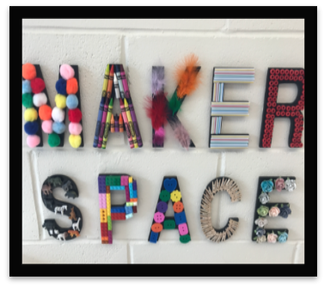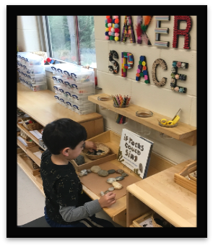

Field Trip
Each year our kindergarteners take a field trip to Philadelphia to see a play at the Arden Children’s Theater. They will also have an opportunity to experience traveling on a school bus.

Graduation
Our Kindergarten students eagerly anticipate our Graduation Ceremony. The children learn traditional folk songs, dances, and prepare speeches for this special occasion. They receive diplomas and gifts in recognition of the hard work they have put in over the years.

